EFDAN Meeting –Agenda
1-2 June 2015
DEVCO, rue de la Loi 41, room 07/23, Brussels

Monday 1 June
14.00 Introduction by the European Commission (R. Ridolfi, Director Sustainable Growth and Development))
14.15 Follow up of last year EFDAN meeting (BMZ/GIZ)
14.30 – 16.00 Exchange of views on recent developments:
- CFS 41 - Recommendations on sustainable fisheries and aquaculture for food security and nutrition (Short introduction by I. Viallon, DEVCO C1)

- FAO Conference on Tenure Rights (Debriefing by G. Greig, SIDA)

- Implementation of the FAO Voluntary Guidelines on Small Scale fisheries – Global Assistance Programme

- State of play on the Post-2015 (short introduction by DEVCO A1)

- Other coming events 2015-2016? (e.g. UNFSA Review Conference 2016)
16.00 Coffee break
16.15 – 17.30 Donor coordination
- Update on new programmes
- Identification of possible synergies
  - Countries: i.e. Myanmar, Indonesia etc
  - Issues: i.e. Working conditions in the fisheries sector
- How to ensure the continuation of our actions? (F. Henry, AFD)
17.30 – 17.45 Cofish.org reviewed website

Tuesday 2 June
9.00 Welcome coffee
9.15 Discussion on Western Africa
- Study on the evolution of the small pelagic fisheries in North Western Africa and possible impacts on nutrition and food security in Western Africa (I. Viallon/B. Caillart(tbc))

- Research, data collection and stock assessment – the Nansen Programme and the role of CECAF (NORAD in association with FAO)

- RFBs institutional assessment and rationalization (S. Douala, FISHGOV programme)
12.30 -13.30 Lunch break (provided by DEVCO)
- How to promote transparency in the fisheries sector – EITI and aid conditionality? (Transparency International (tbc) / World Bank)

- IUU fishing in Western Africa (MARE/DEVCO + NORAD)

- MPAs in Western Africa: how can they play a role in fisheries management? (F. Henry, AFD)
16.30 Presentation by the World Bank, Senior Director Paula Caballero
17.00 Conclusion by the European Commission (C. Montesi – Director West and central Africa)
Convivial drink

Additional events
Wednesday 3 June - World Bank presentation of PROFISH+
09:00 – Introductions
09:30 - Introduction to Profish and Objectives of the Workshop (RE Brummett)
10:00 – Review of priorities and geographical foci of WBG, EFDAN and other potential partners
11:30 - Open discussion of priority interventions, opportunities and constraints
13:00 – Lunch and Conclusion

Thursday 4 June- European Development Days:
- 9:00-10:15 - Eating legal and sustainable seafood: How your contribution can positively impact developing countries (WWF)
https://eudevdays.eu/topics/fish-forward-project-2
- 12:30-13:45 - Balancing carrots and sticks for fisheries management: Lessons from Bangladesh (IIED)
https://eudevdays.eu/topics/economic-incentives-fisheries-management-bangladesh-1
Address: Rue de la Loi 41, Brussels
Metro: Arts / Loi
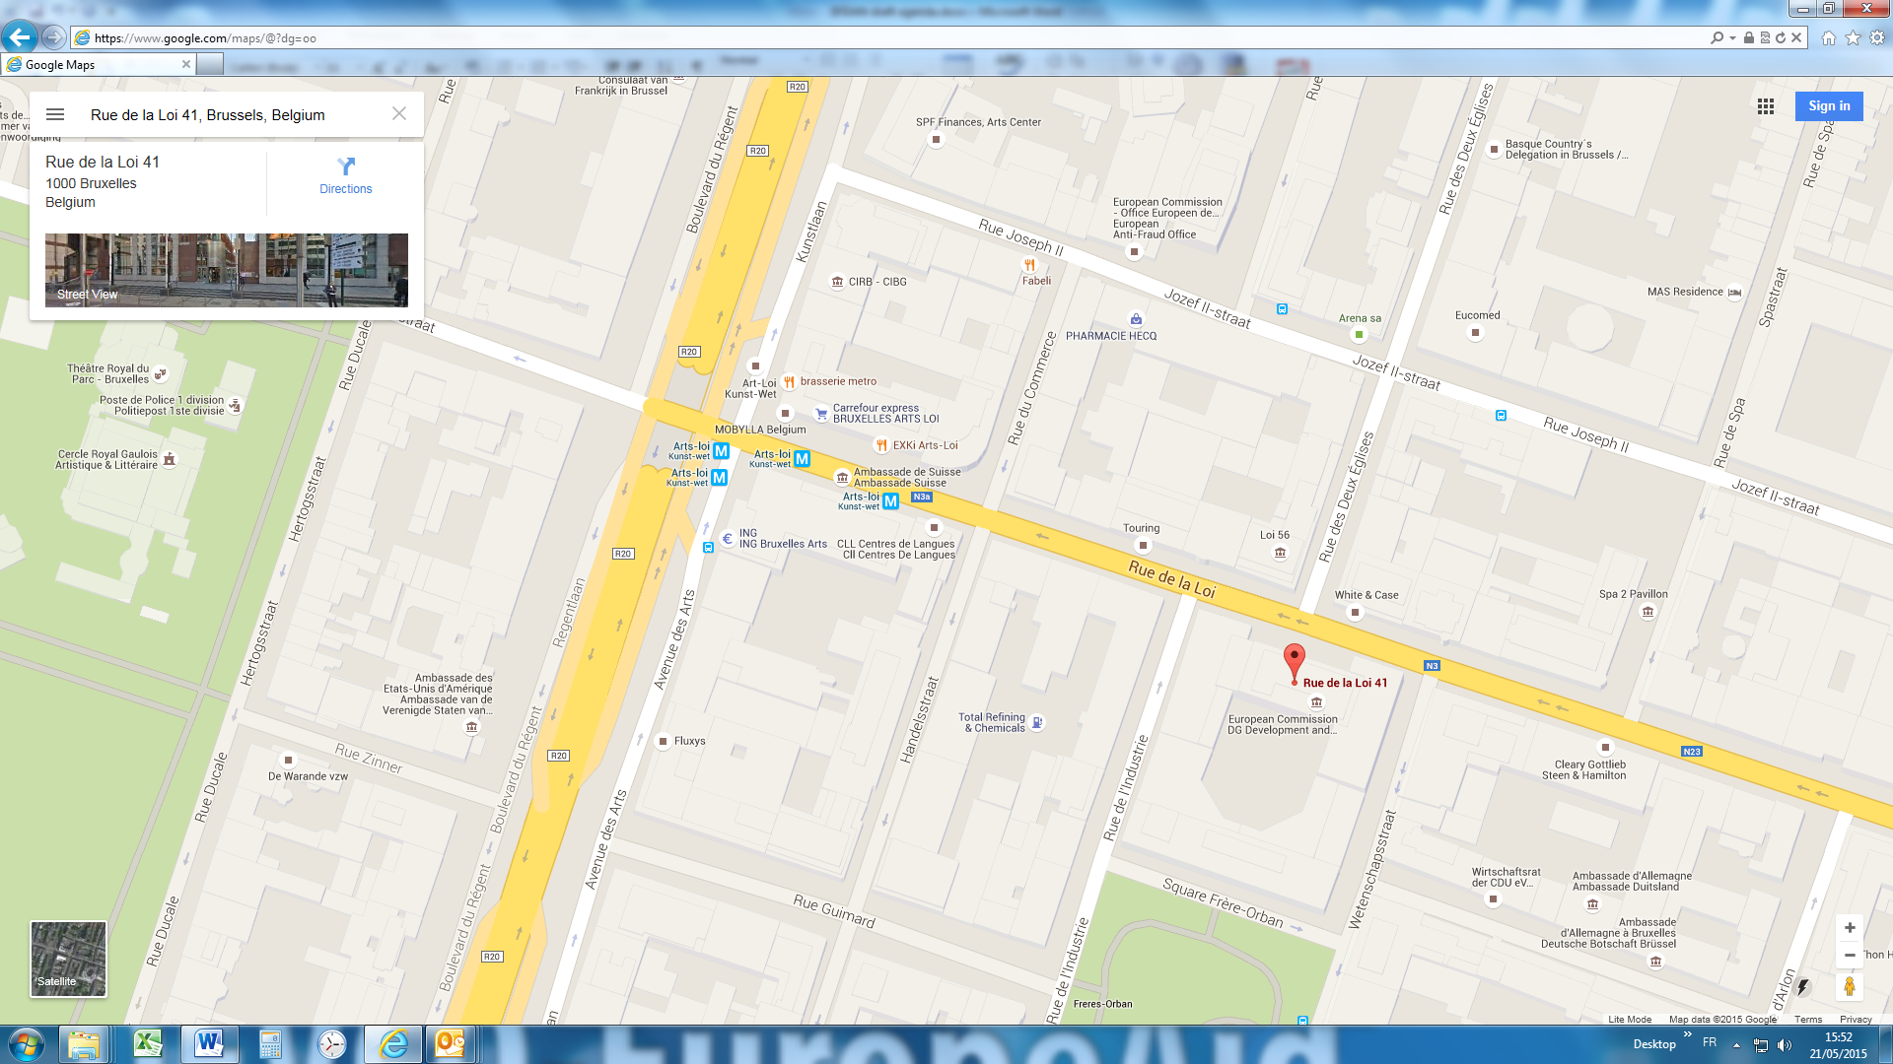
Contact person: Isabelle Viallon, isabelle.viallon@ec.europa.eu, tel: +32 2 29 56 212, mobile: + 32 479 41 58 45

